Assignment 3
Name: Digvijay Vikas Sawant
PRN: 260240125023

- Create a file and use chmod to set it to rwx.

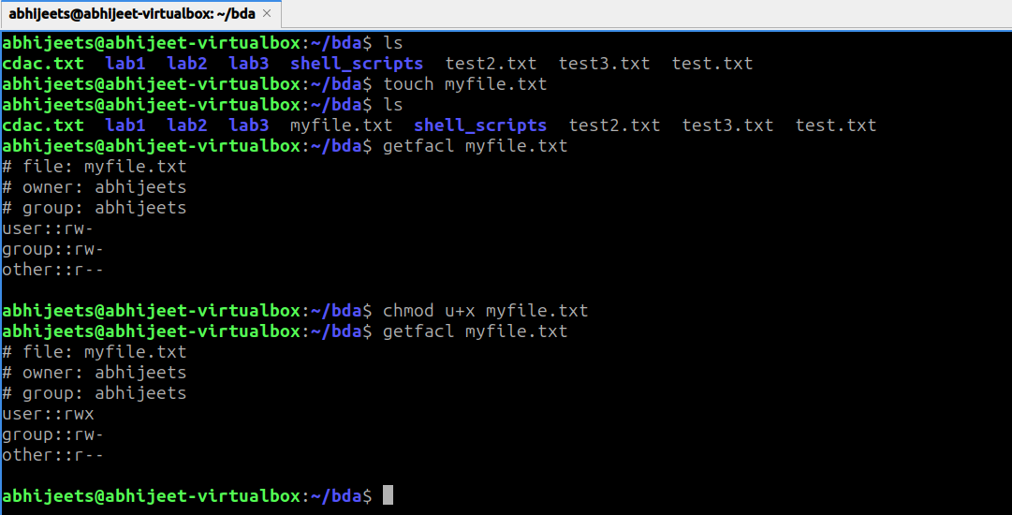

- Create another file and change its owner using chown.

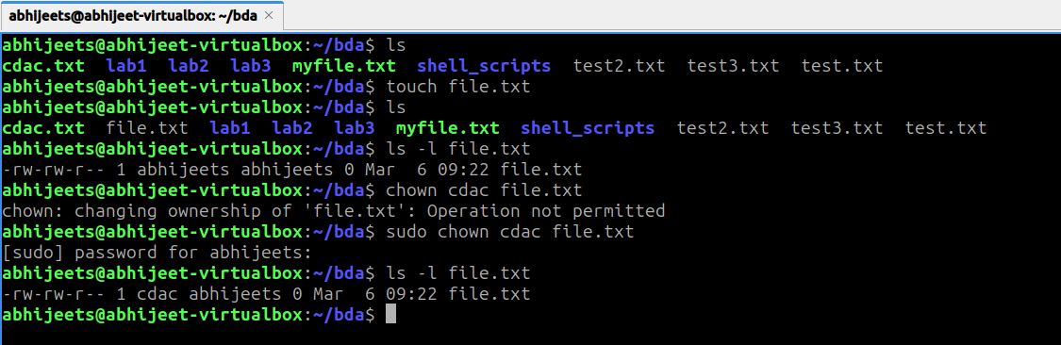

- Create a group and assign file access using chgrp.

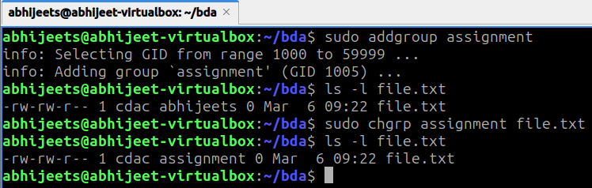

- Open a file in vi, insert text, save, and quit.

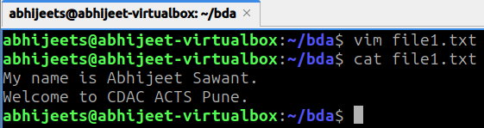

- In vi, use find and replace to change a word in the file.

